Obesity
Impact Score
0 30 30
A weight that is higher than what is considered to be healthy, determined by a Body Mass Index (BMI) of ≥ 30 (calculated using height and weight)

Health Impacts  Increased risk of:  - Stroke  - Heart disease  - Diabetes  - Certain types of cancer  - Poor mental health  - Arthritis  139 deaths per 100,000 persons, annually  Source: CDC | Comparison  Obesity, Marion Co. vs. other locations, 2015-2016  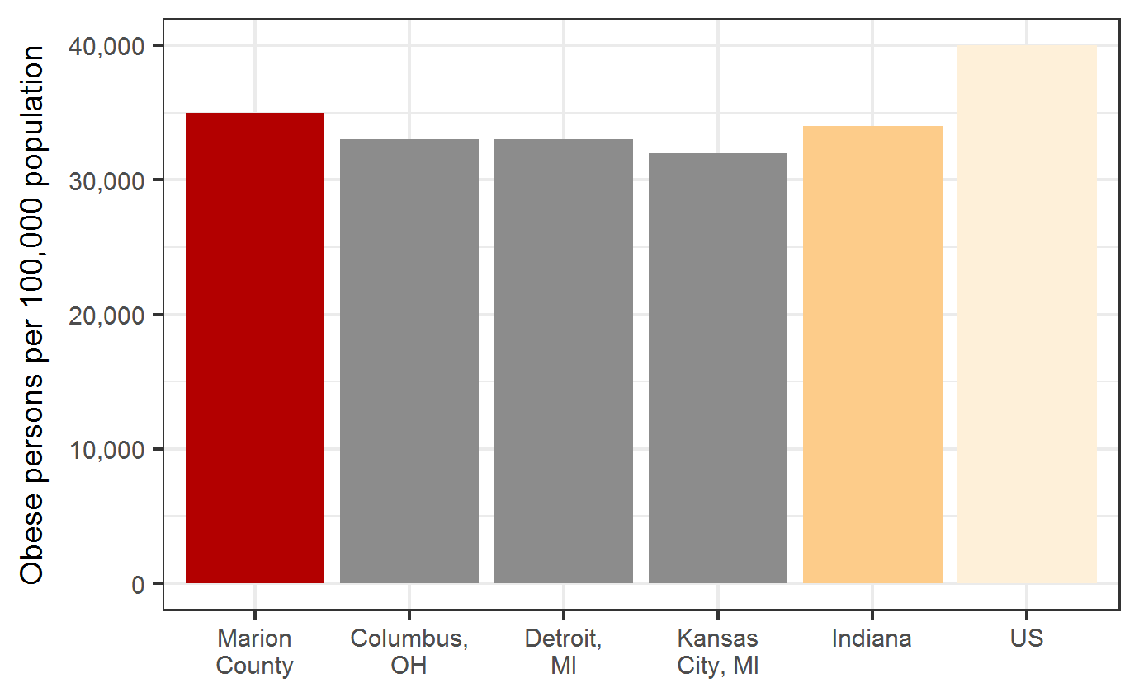  Source: Big Cities Health Coalition
Treatment  - Exercise  - Increase access and consumption of nutritious foods | Trend  Marion Co. Obesity, 2011-2016  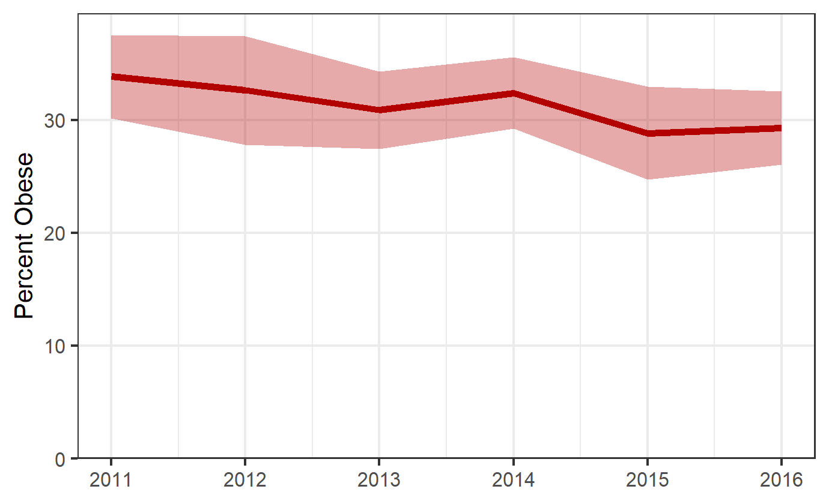  Source: BRFSS

Risk Factors

Behavior  - inadequate exercise: < 150 minutes of moderate exercise and 2 days of strength training  - unhealthy diet: lacking fruits, vegetables, whole grains, and lean protein, and drinking water  Source: RWJF |  | Environment  - Lacking a safe environment for walking/biking  - Friends and family members who are not active and do not eat healthy foods  Source: RWJF

Equity
Obesity by Gender  Males reported a higher rate of obesity compared to females in Marion County. | Obesity by Gender, Marion Co. 2016  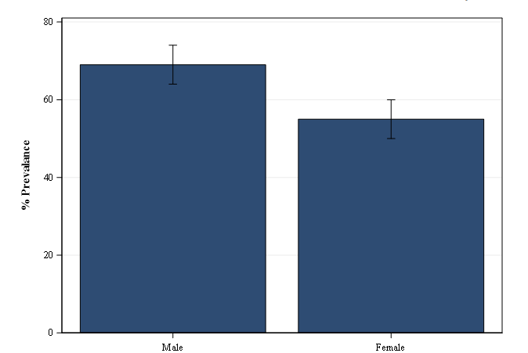  Source: BRFSS
Obesity by Race/Ethnicity, Marion Co. 2016  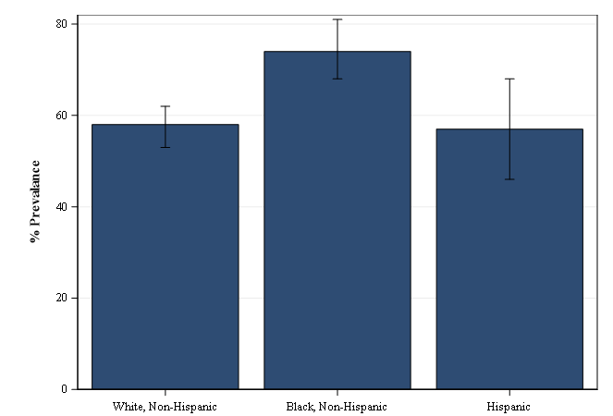  Source: BRFSS |  |  | Obesity by Race/Ethnicity  Non-Hispanic African Americans reported a higher rate of obesity compared to their non-Hispanic White and Hispanic counterparts in Marion County.

